# EXP-1

CREATING TABLE STUDENTS:-

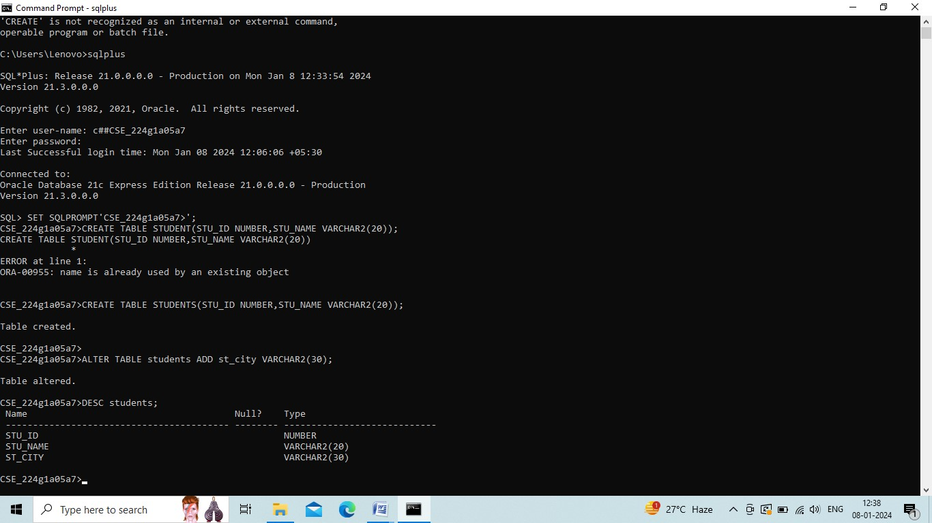

ALTER TABLE STUDENTS:-



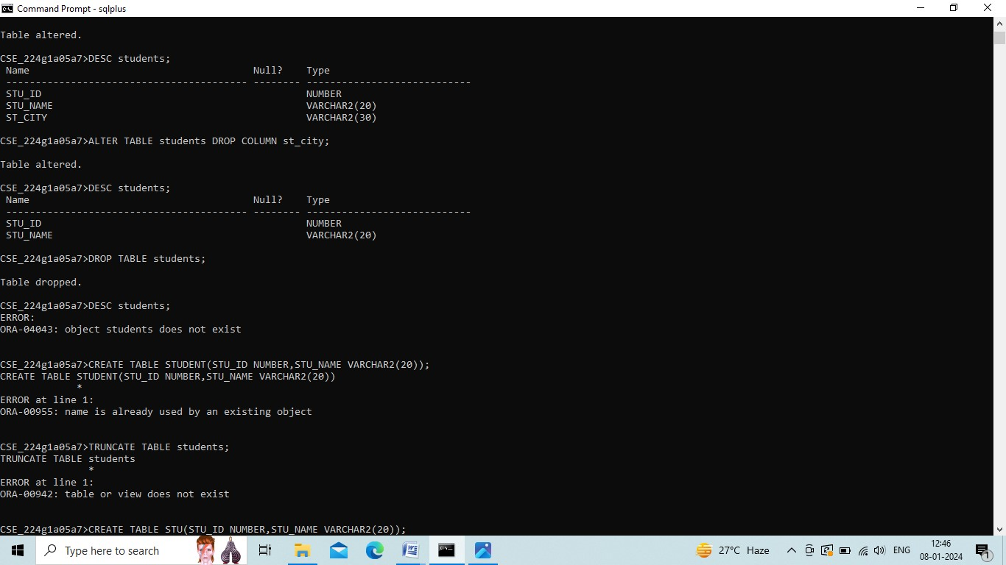

DROP TABLE:



TRUNCATE TABLE:-

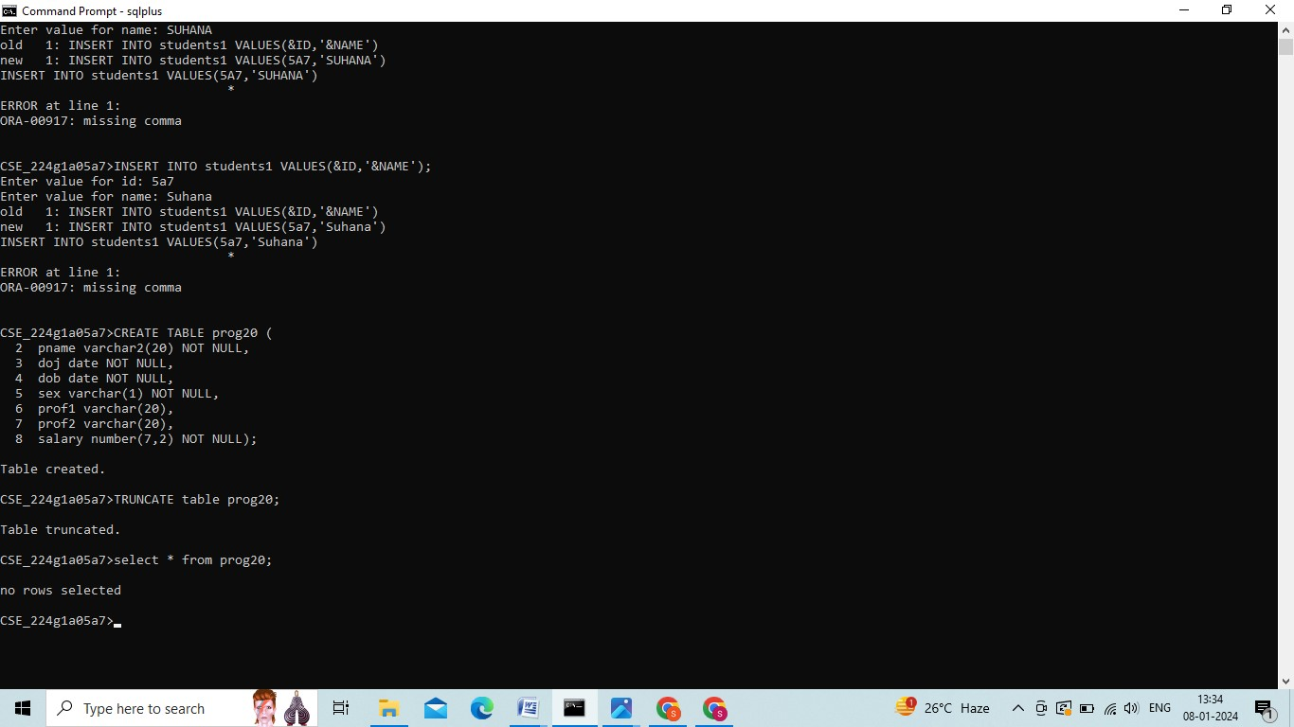



CONCLUSION: In This Lab, We Successfully Completed DDL COMMANDS.

# 

# Exp-2

**DML COMMANDS:-**

CREATING TABLE STUDENT2:-

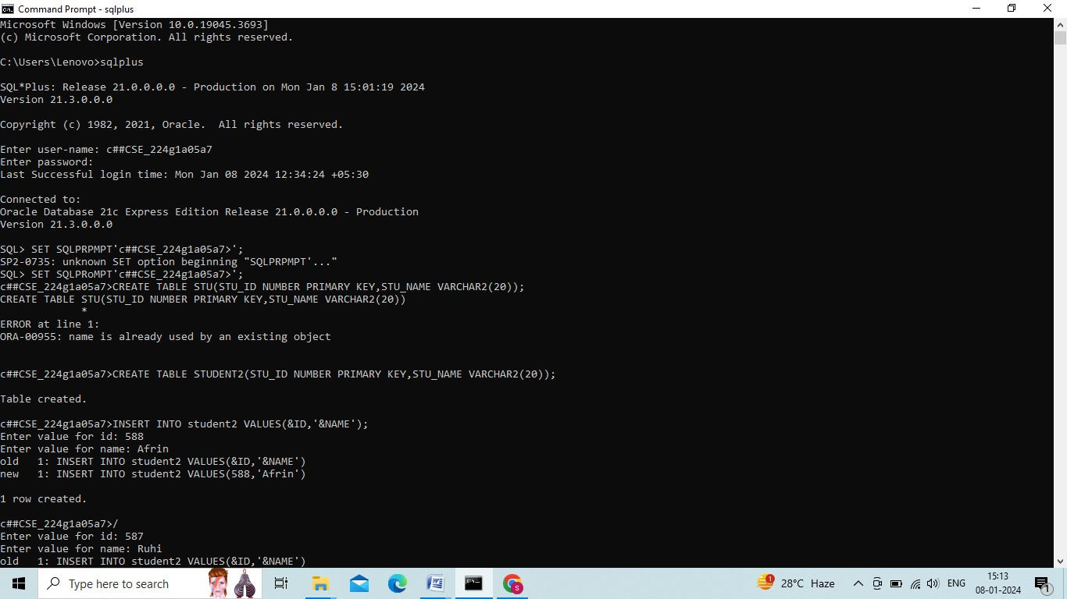

INSERTING VALUES:-

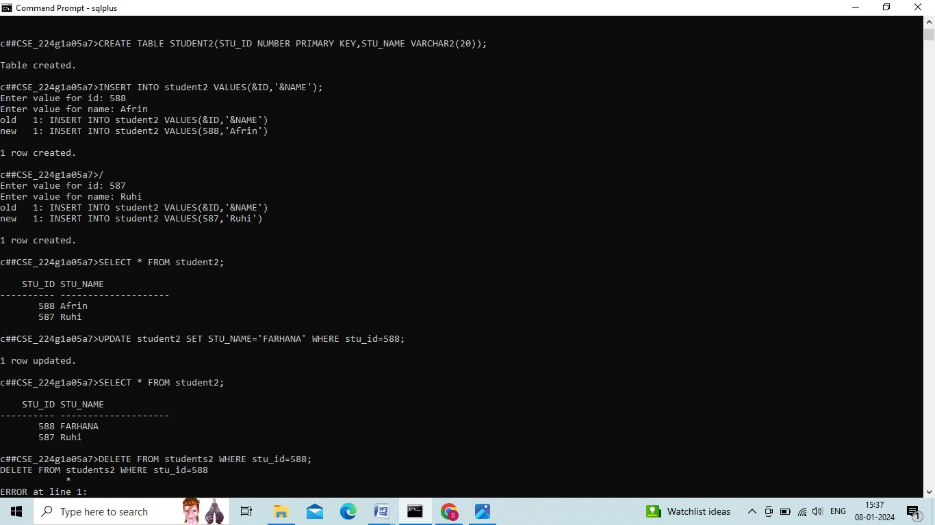

UPDATE COMMAND:-



DELETE COMMAND:-

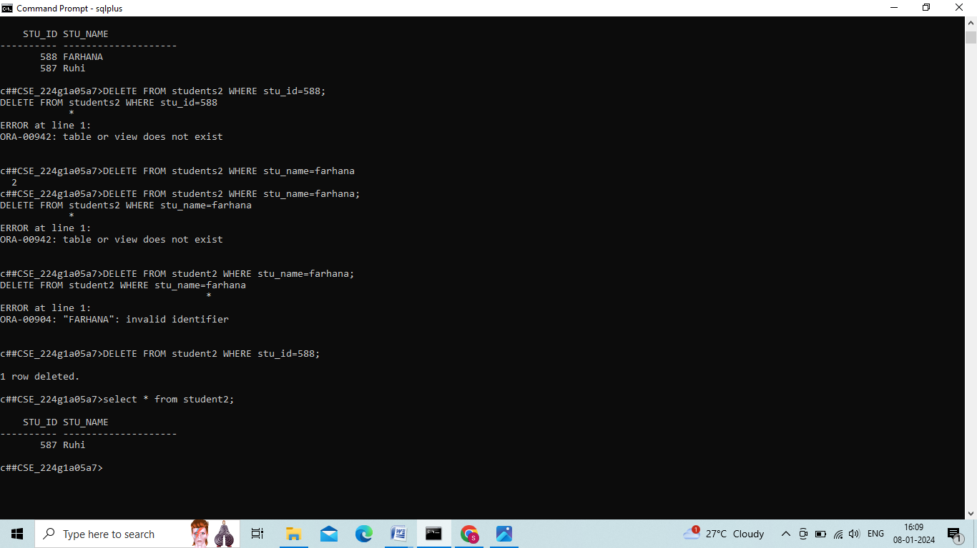

SELECT COMMAND:-

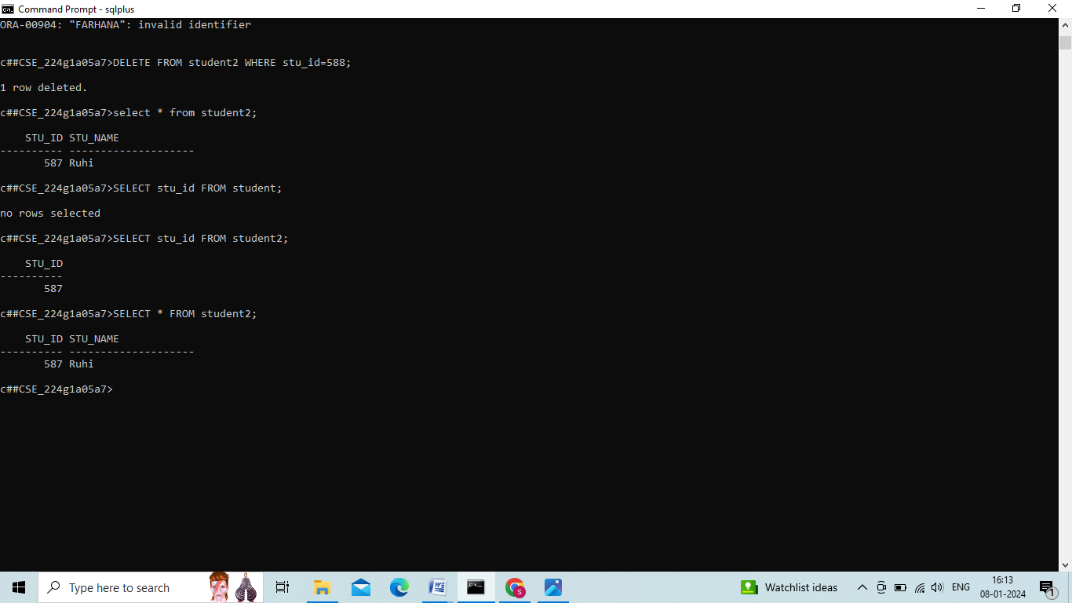



**Conclusion: In** this lab, we successfully completed DML commands.

# Exp-3

**VIEWS:**

CREATE TABLE

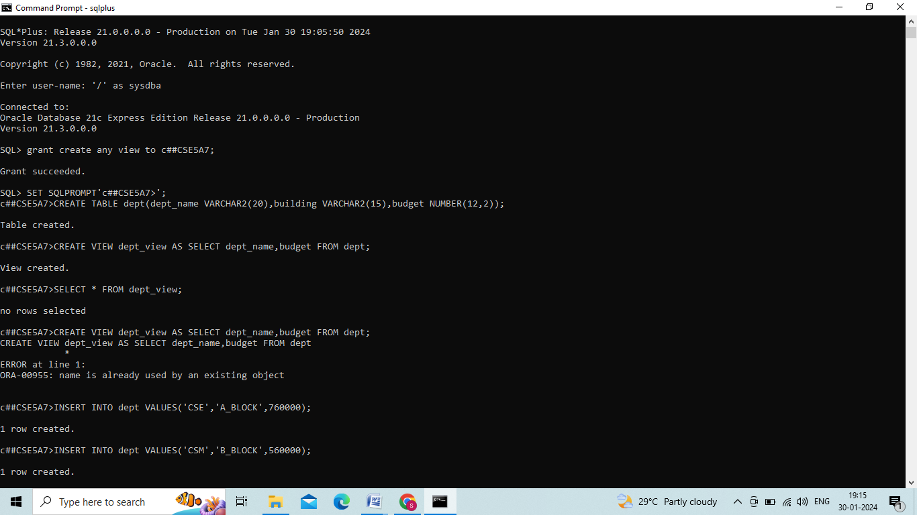

CREATE VIEW

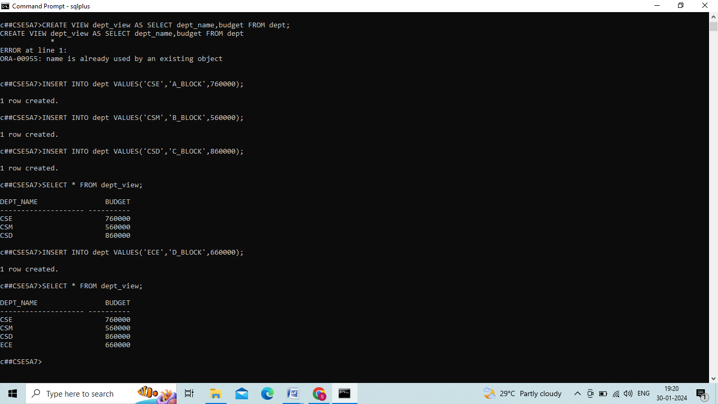

INSERTING VALUES





UPDATE VIEW

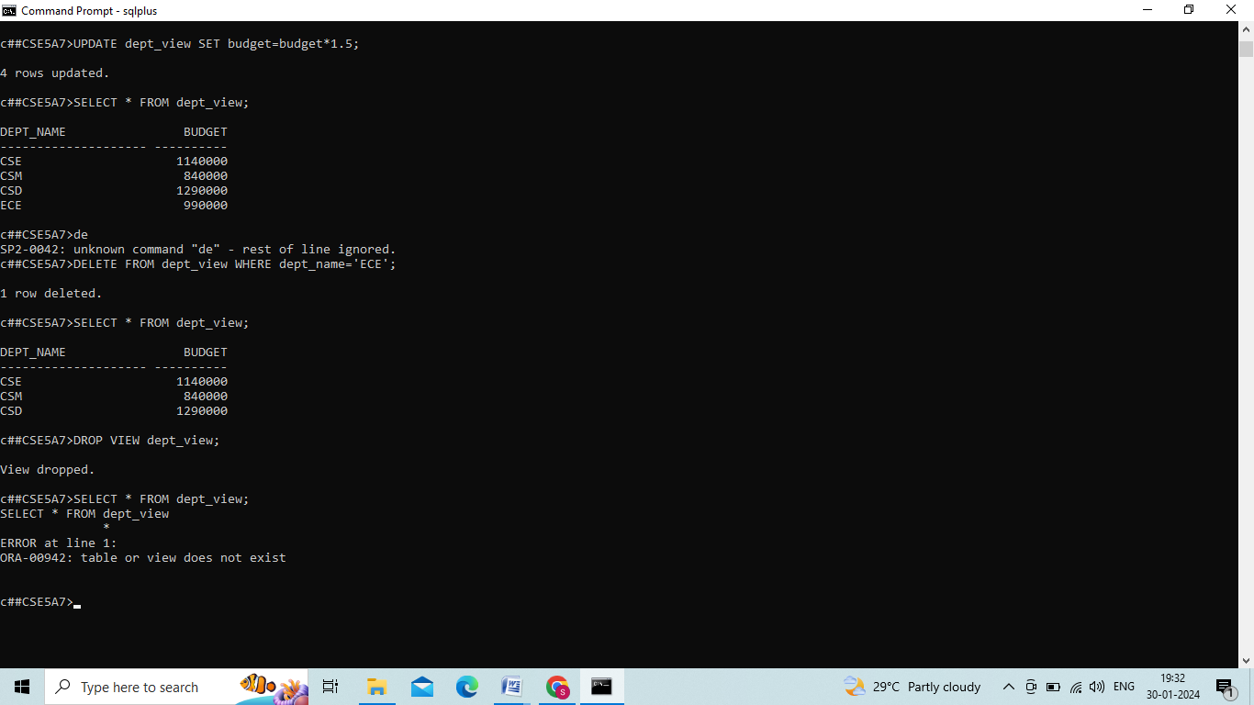

DELETE VIEW



DROP VIEW

**CONCLUSION:** In this lab, we successfully completed views(create view, update view, delete view).

# EXP-4

**RELATIONAL SET OPERATIONS:**

CREATE TABLE 1:

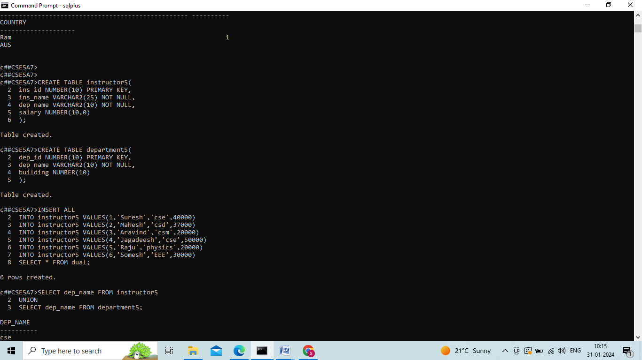

CREATING TABLE 2:

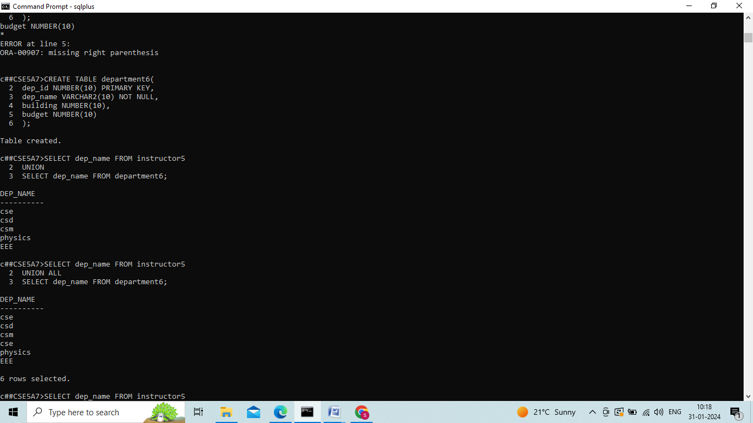

INSERTING VALUES



UNION:



UNION ALL:



INTERSECT:

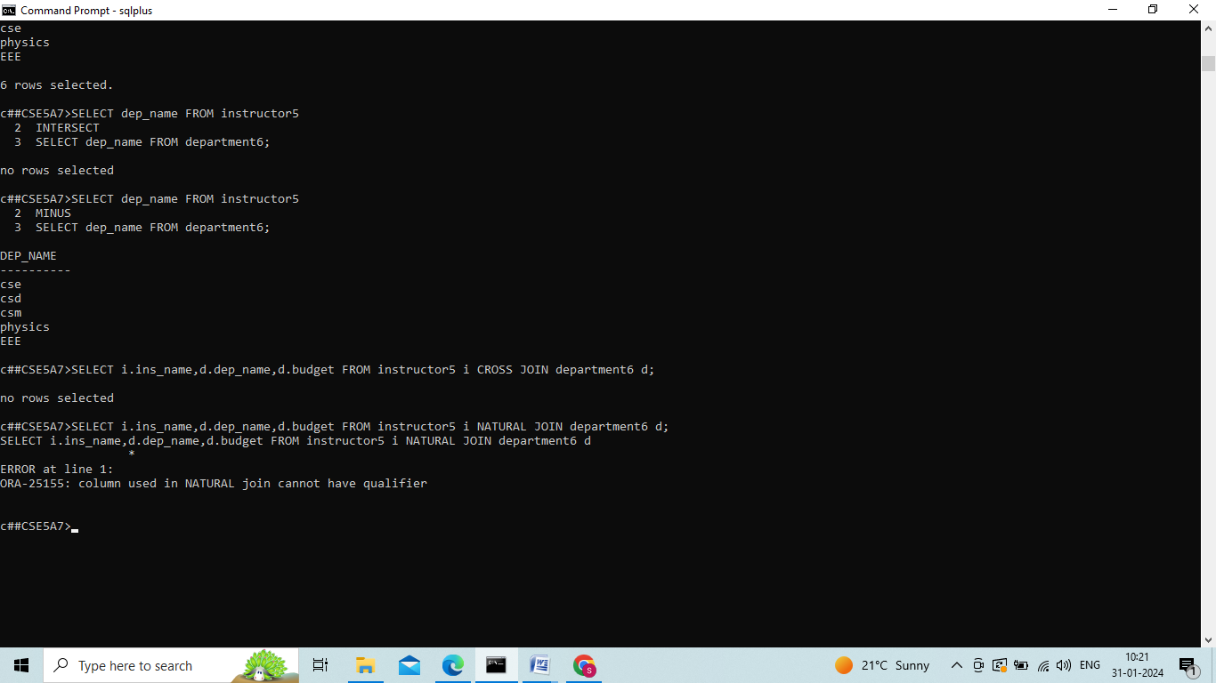

MINUS:



CROSS JOIN:



**CONCLUSION: In this lab, we successfully completed Relation set operations.**

## 

## EXP-5

**SPECIAL OPERATIONS:**

CREATE TABLE:

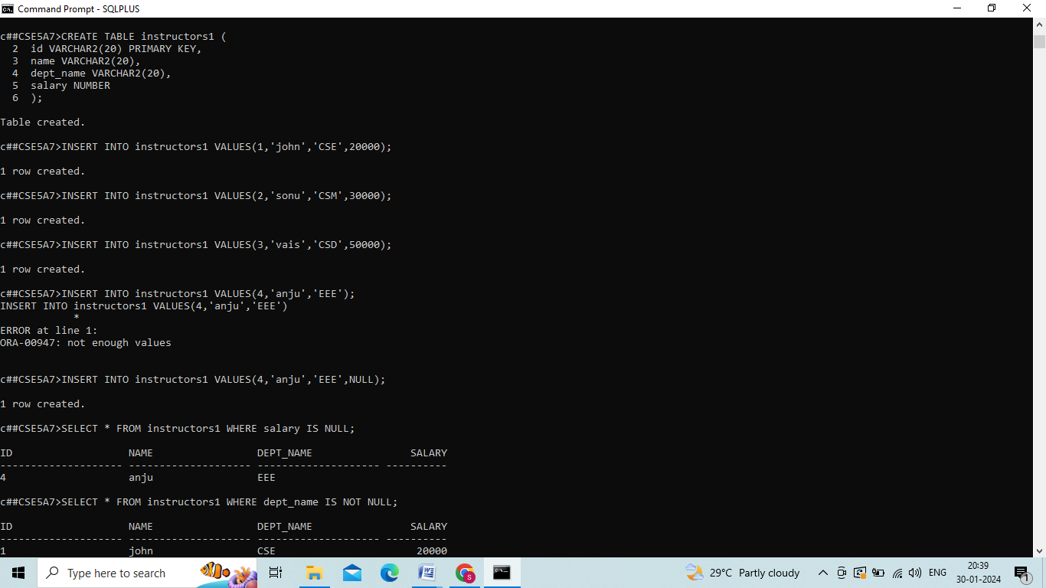

INSERT VALUES:



IS NULL COMMAND:

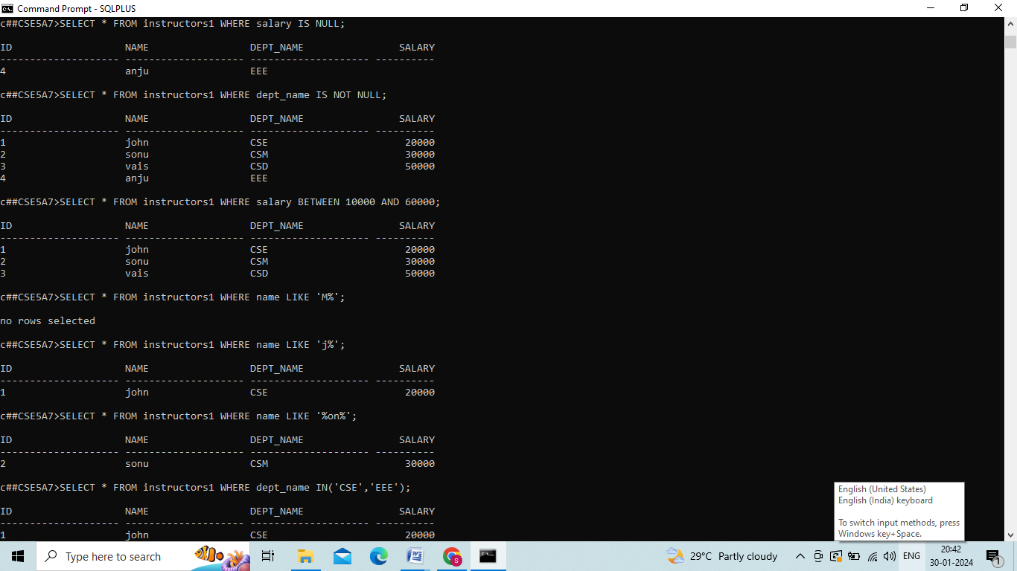

IS NOT NULL:



BETWEEN COMMAND:



LIKE COMMAND:



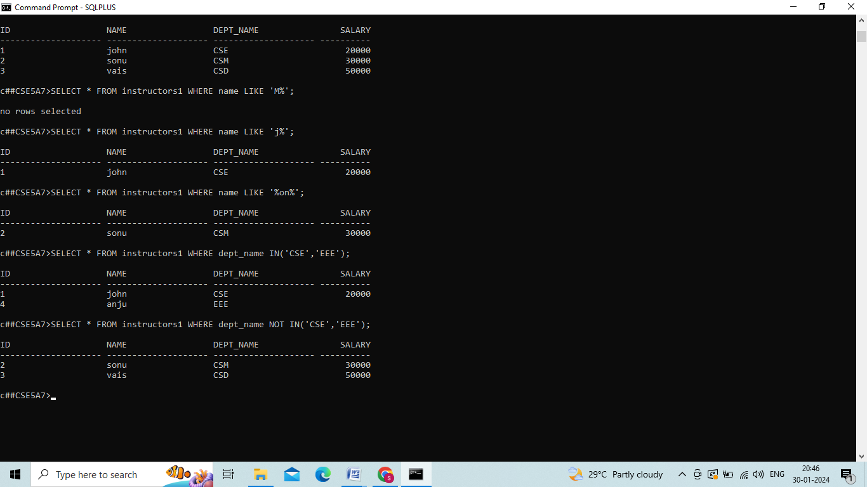

IN COMMAND:



NOT IN COMMAND:



**CONCLUSION: In this lab, we successfully completed special operations.**

## EXP-6

**JOIN OPERATIONS:**

CREATING TABLE:

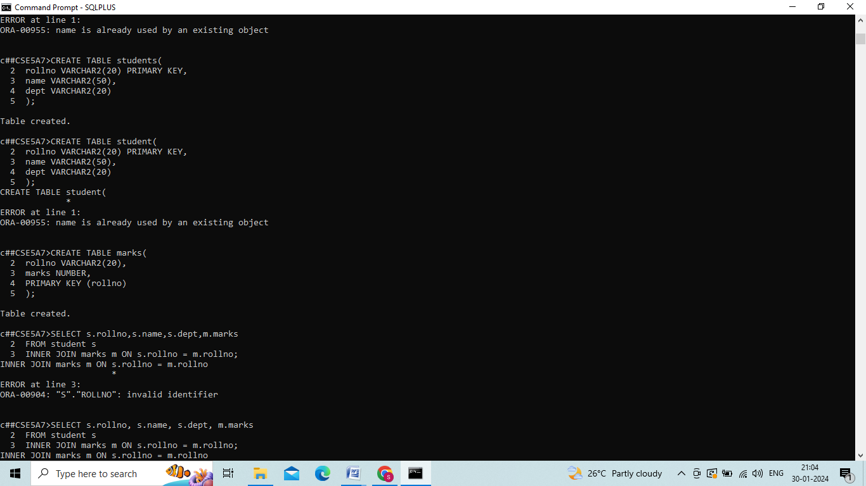



INNER JOIN

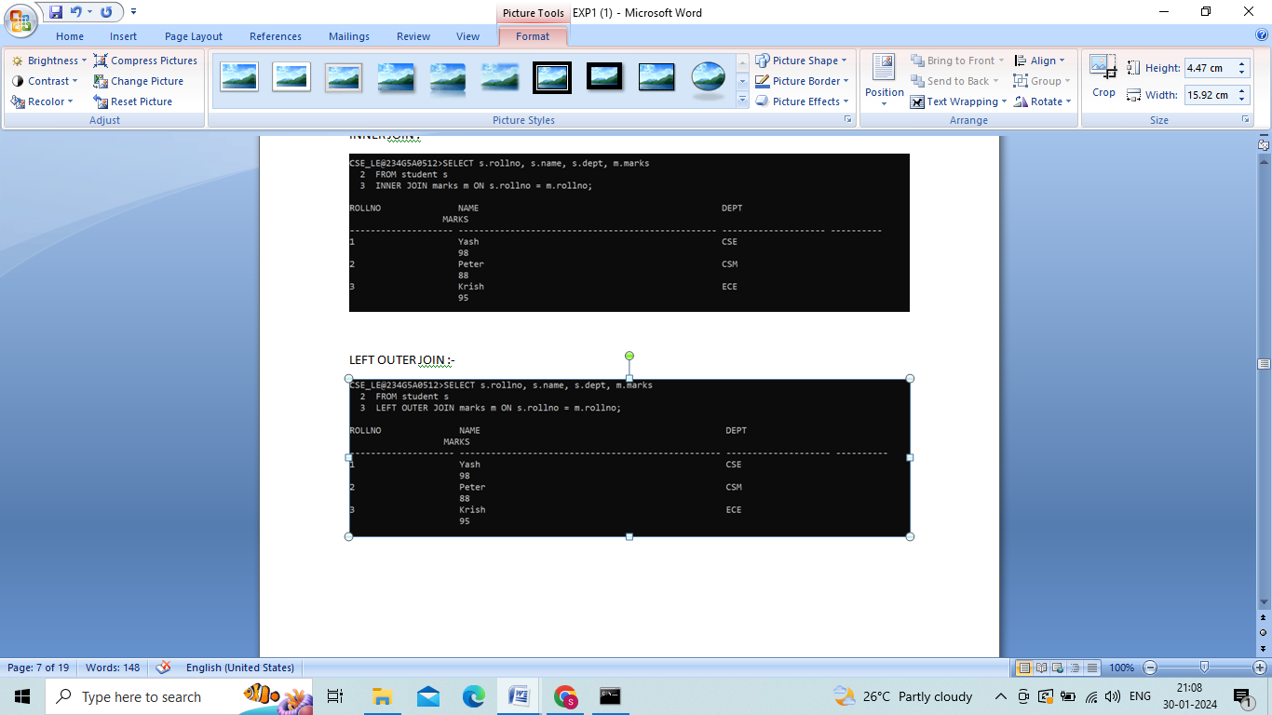

LEFT OUTER JOIN:



RIGHT OUTER JOIN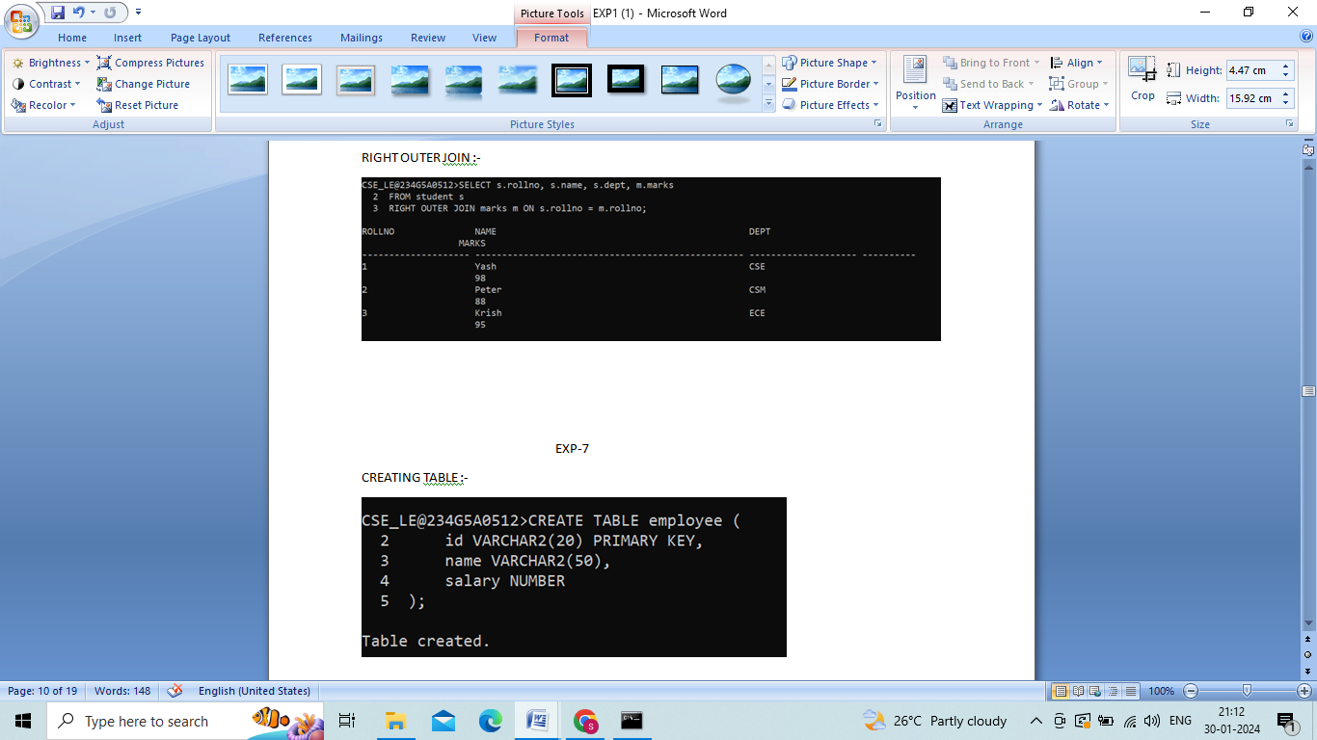

**CONCLUSION: In this lab, we successfully completed join operations**

## EXP-7

CREATING TABLE:

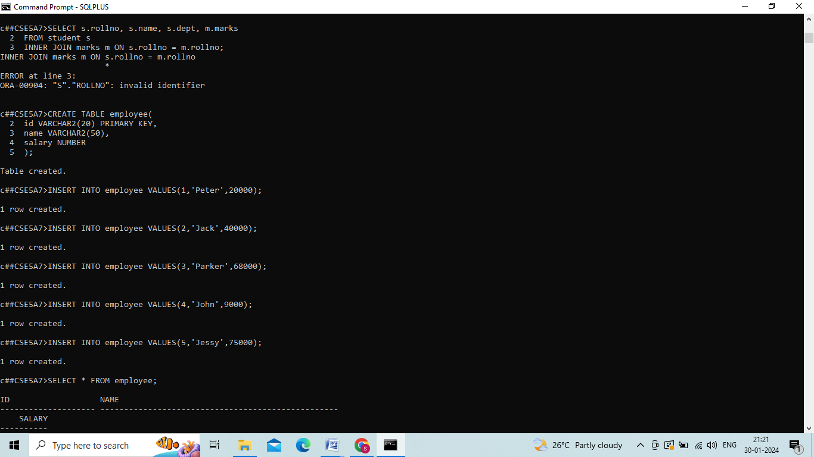

AVERAGE:

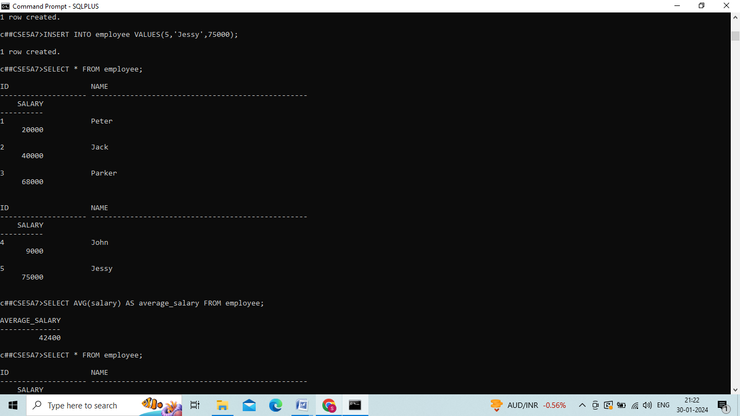

MIN:

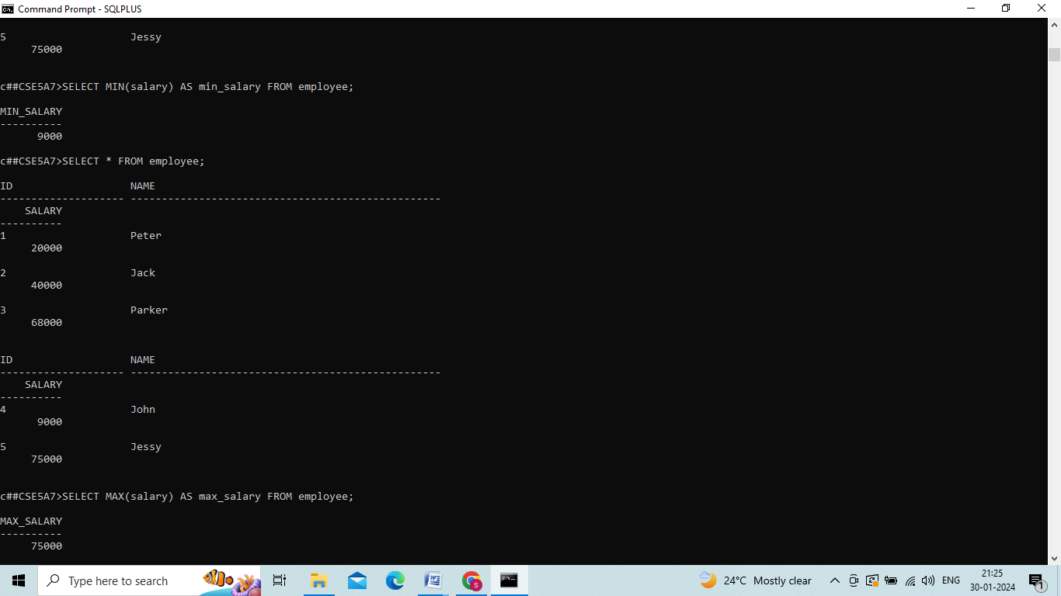

MAX:

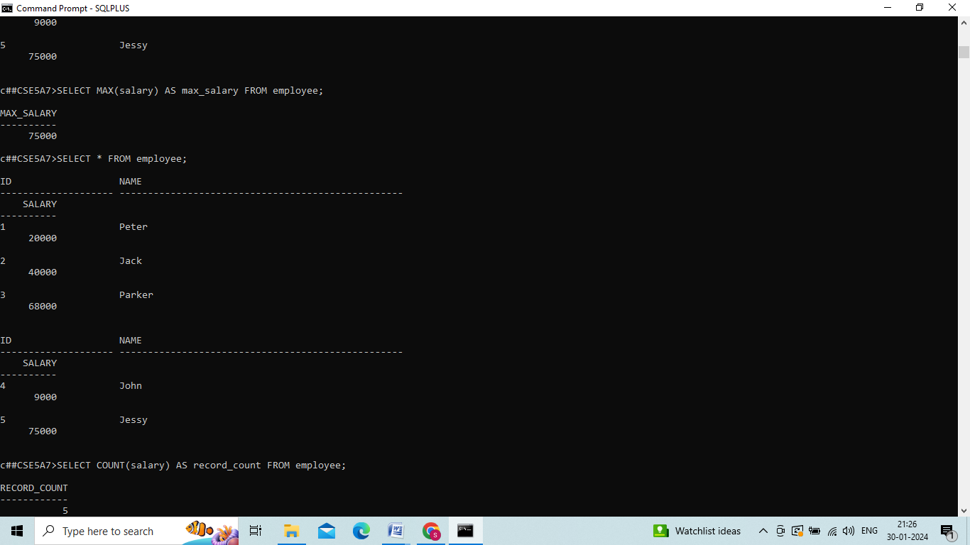

COUNT:

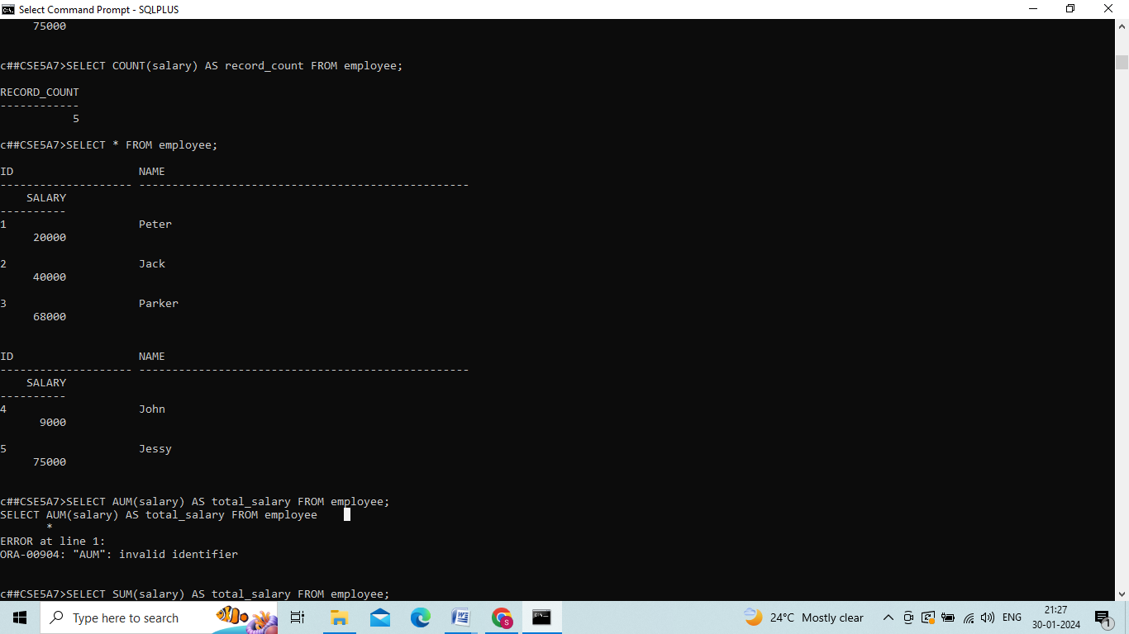

SUM:

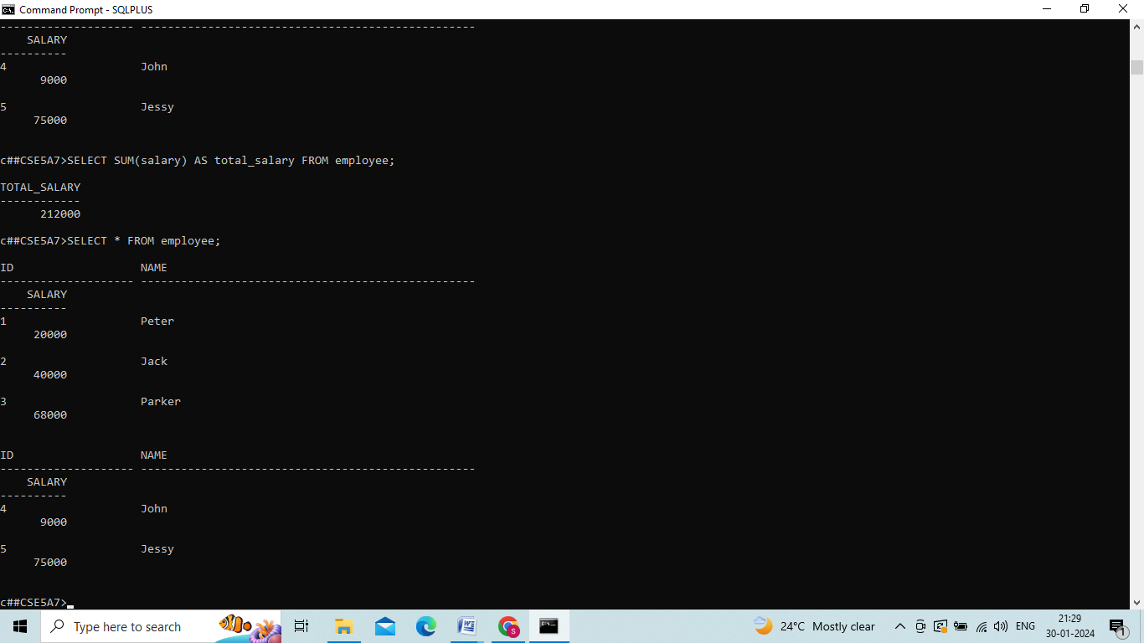

**CONCLUSION: : In this lab, we successfully practiced SQL Queries to perform AGGREGATE operations**

## EXP-8

CREATE TABLE

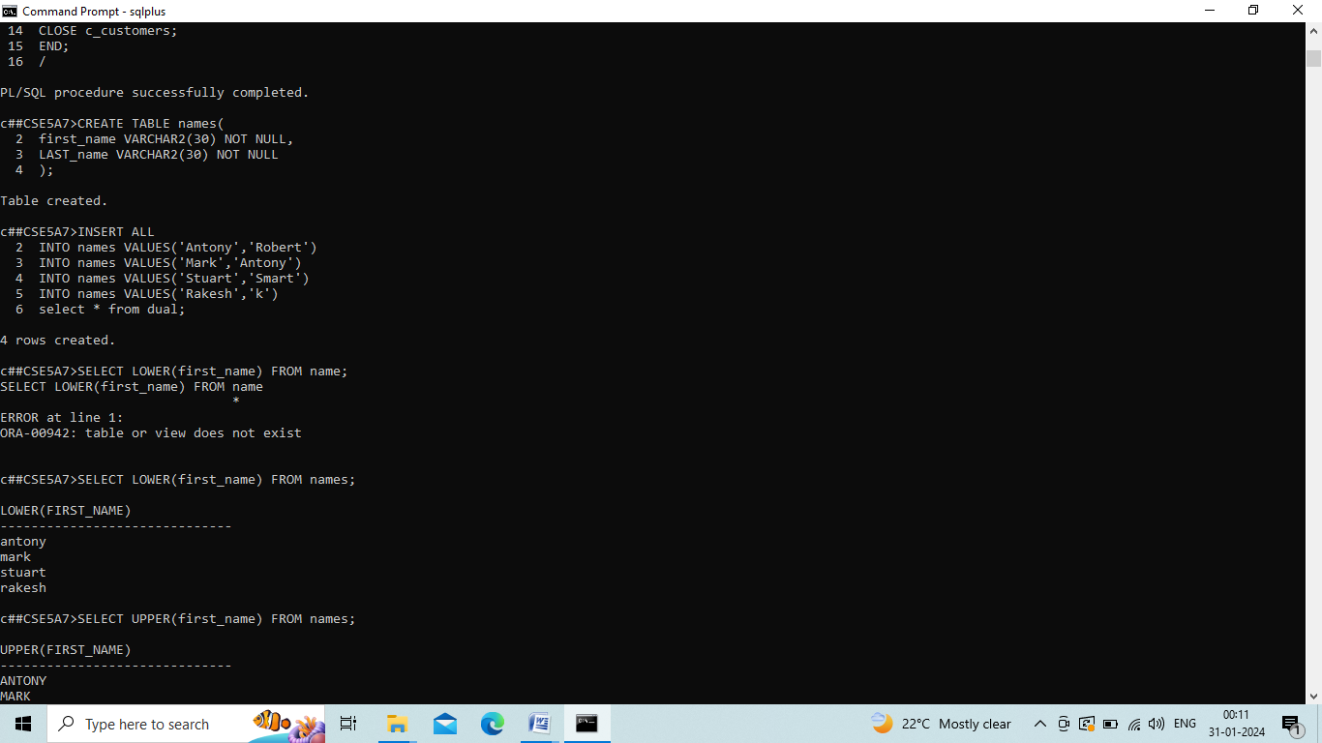

INSERT VALUES:



SELECT LOWER:

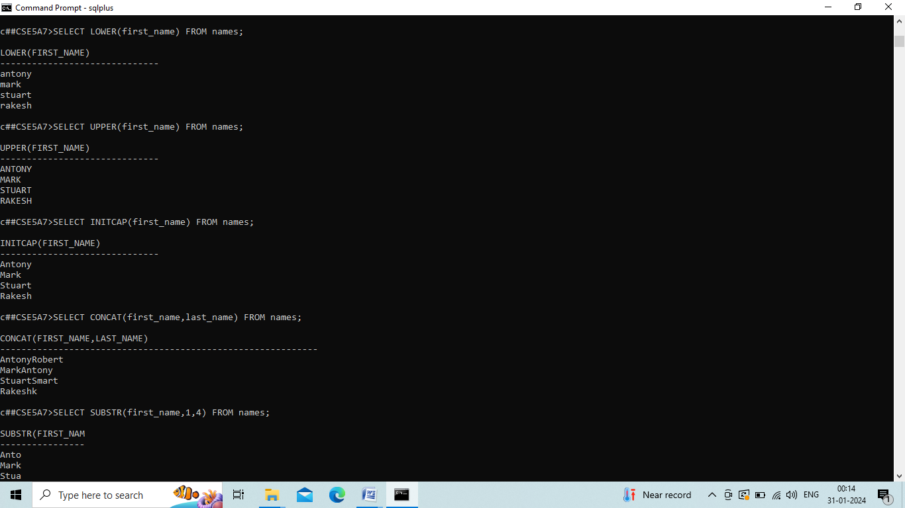

SELECT UPPER:



SELECT INITCAP:



SELECT CONCAT:



SELECT SUBSTR:

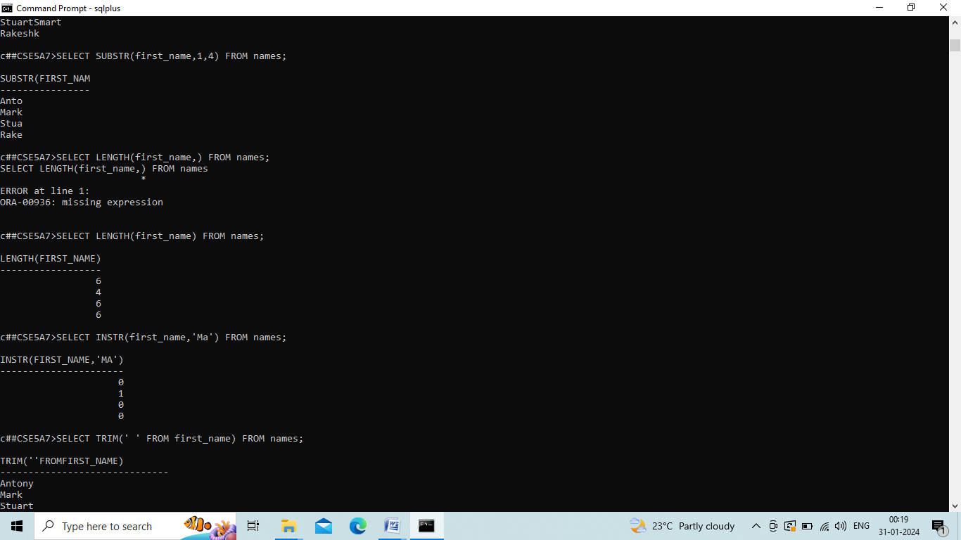

SELECT LENGTH:



SELECTINSTR:



SELECT TRIM:

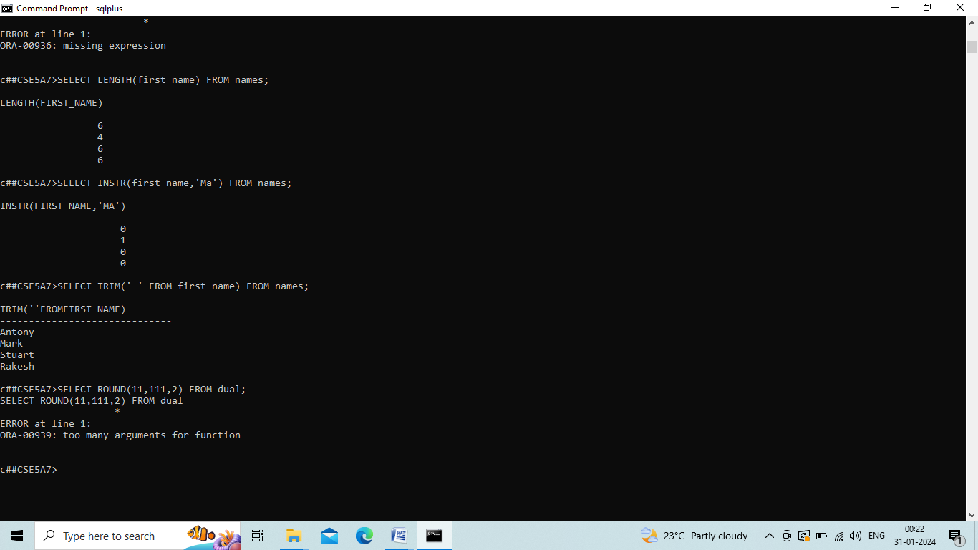

## EXP_9

CREATE TABLE stud:

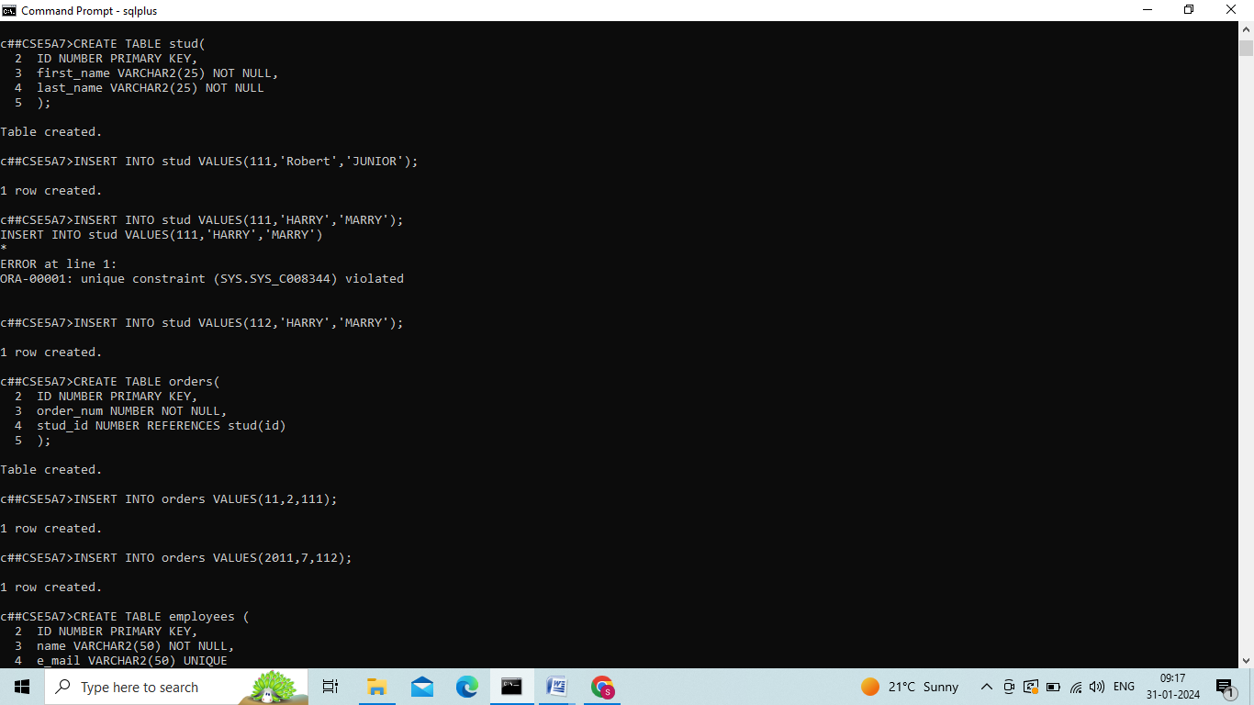

INSERT VALUES INTO stud:



CTREATE TABLE orders:



INSERT INTO orders VALUES:



CREATE TABLE employees:

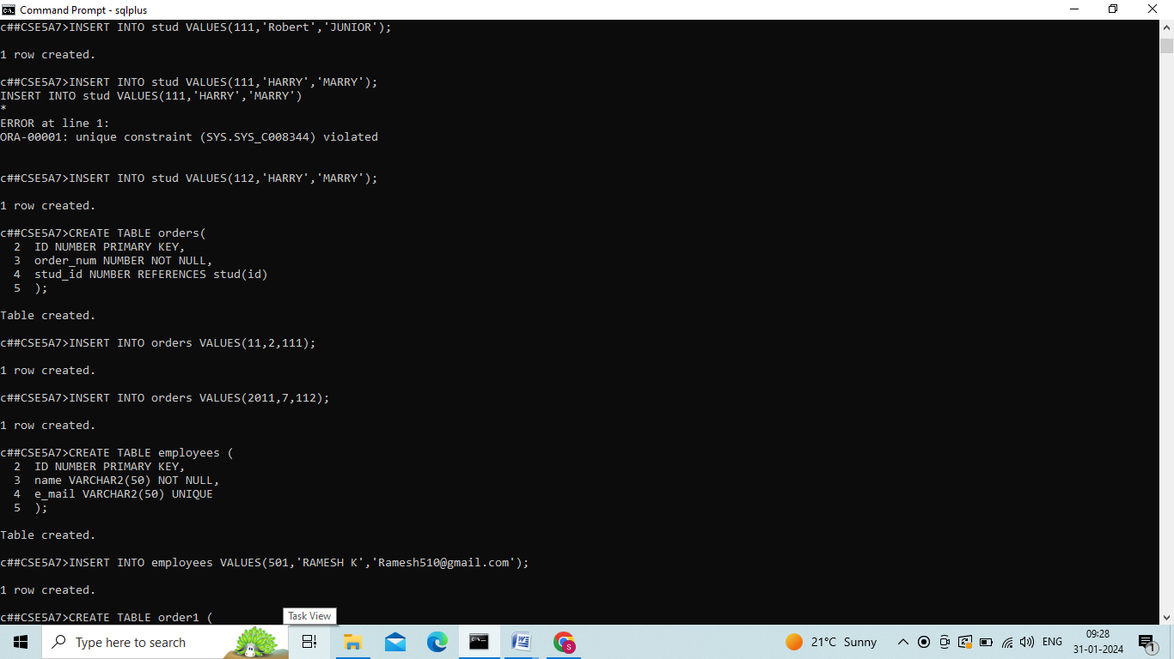

INSERT INTO employees VALUES:

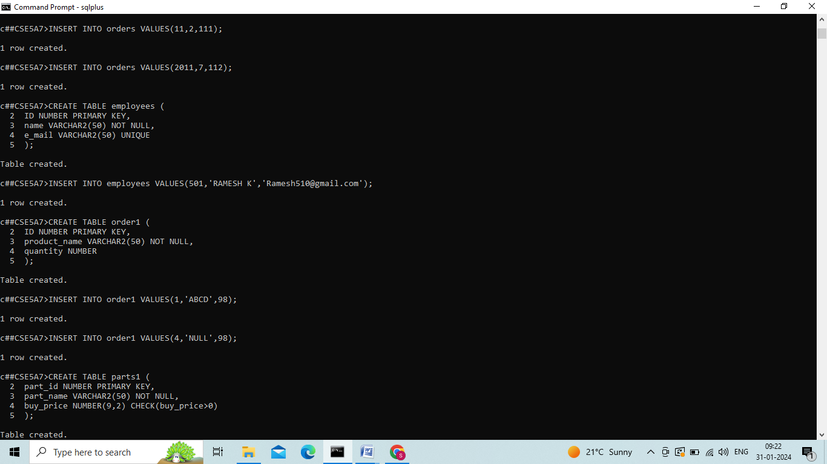

CREATE TABLE order1:

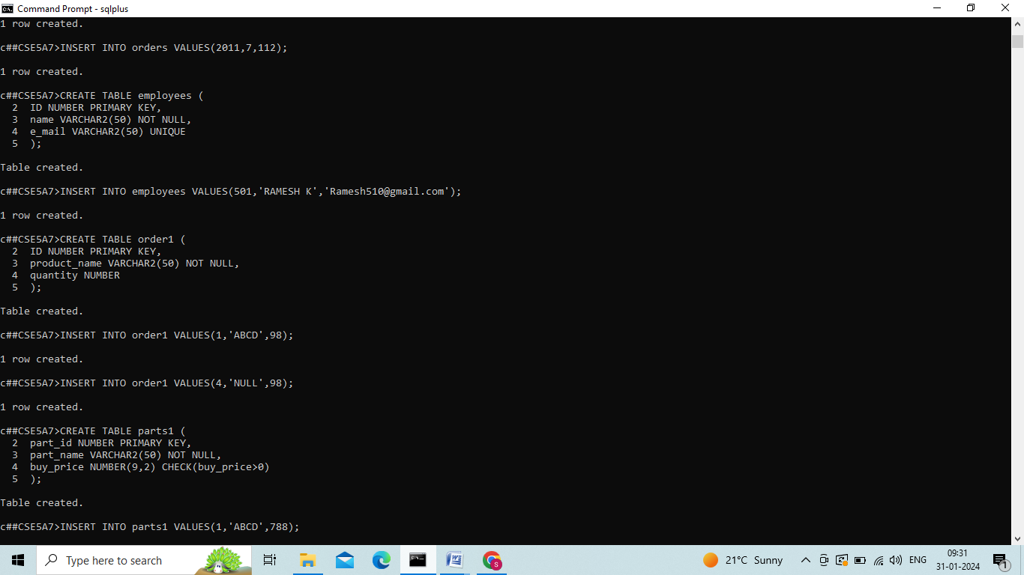

INSERT INTO order1 VALUES:



CREATE TABLE parts1:



INSERT INTO parts1 VALUES:

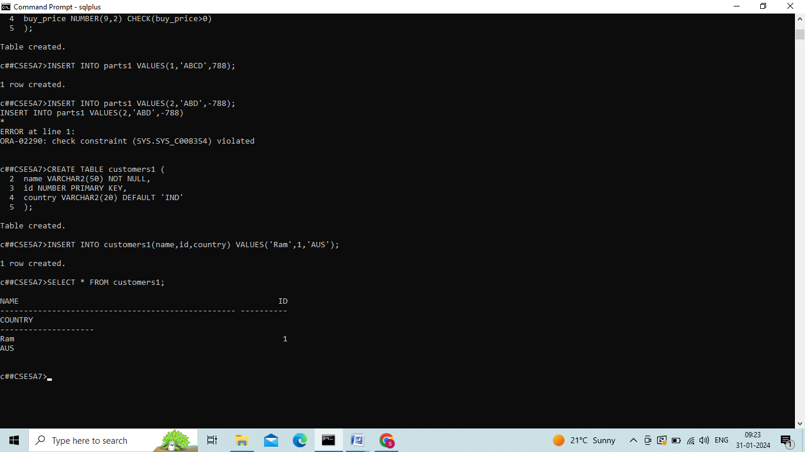

CREATE TABLE customers1:



INSERT INTO customers1 and SELECT*FROM customers1:



**CONCLUSION:** In this lab we successfully executed key constraints.

## EXP-10

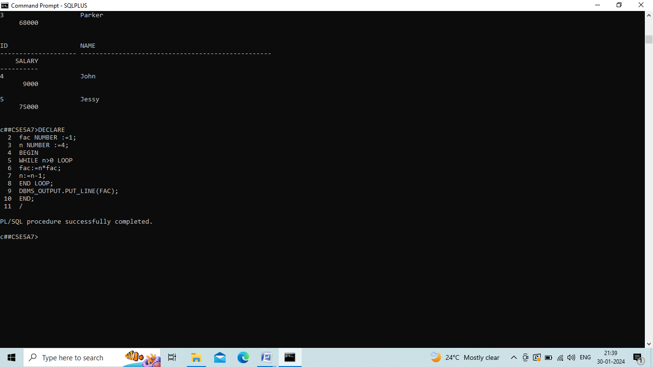

**CONCLUSION:** this In lab, we successfully completed PL/SQL program of factorial numbers

## EXP-11

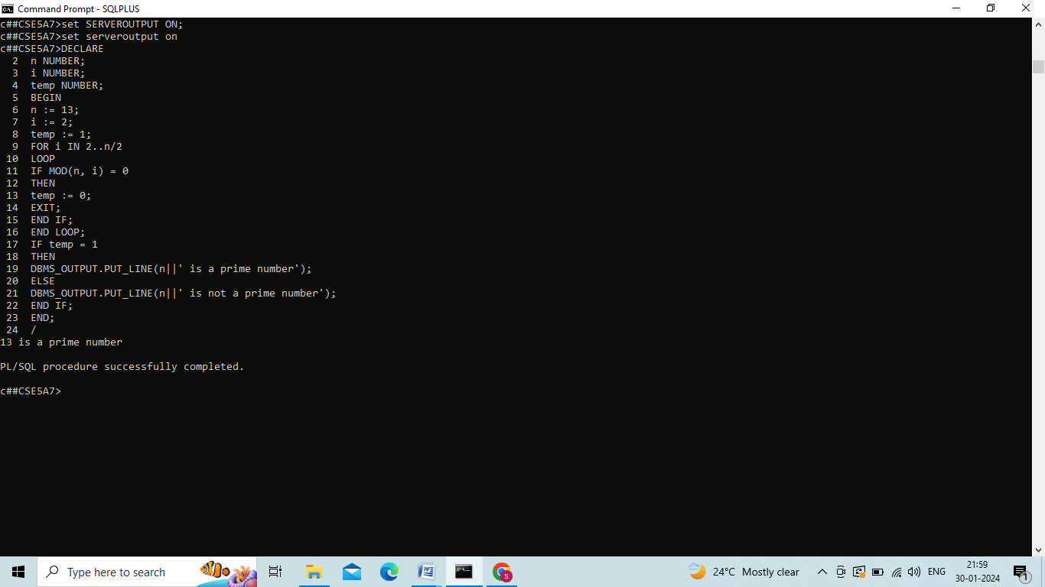

**CONCLUSION:** In this lab, we successfully completed PL/SQL program on given number is prime or not.

## EXP-12

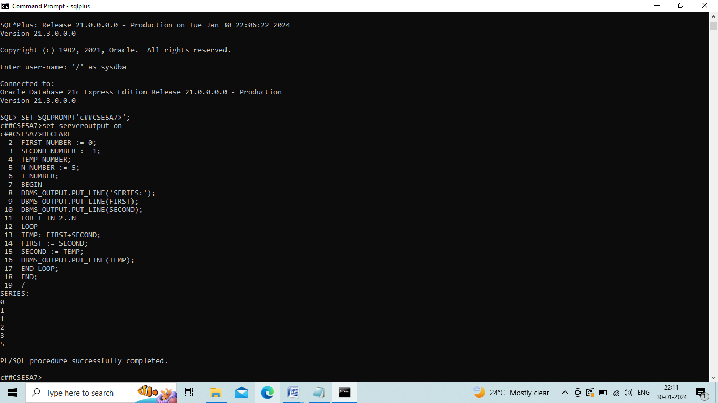

**CONCLUSION:** In this lab, we successfully completed PL\SQL program on Fibonacci series.

## EXP-13

CREATING TABLE AND INSERTING USER:-

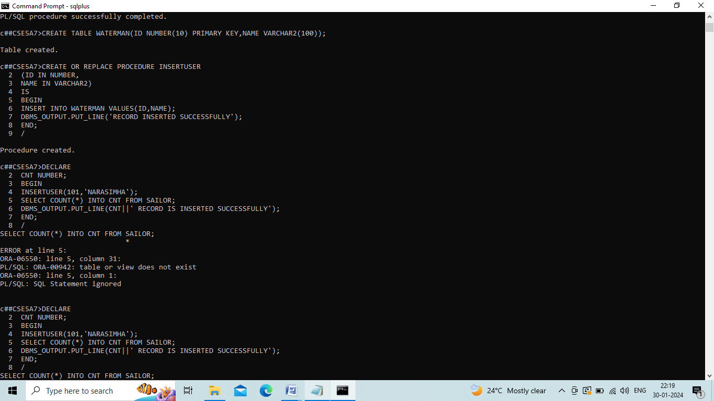

PROGRAM:



**CONCLUSION:** In this lab, we successfully practiced How to write a program to implemented stored Procedure on table

## EXP-14

CREATING FUNCTION:

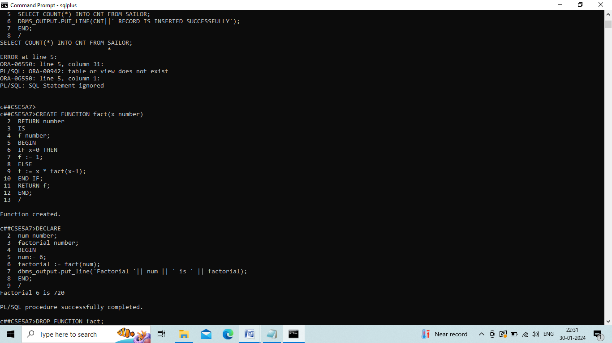

PROGRAM:



DROP FUNCTION:

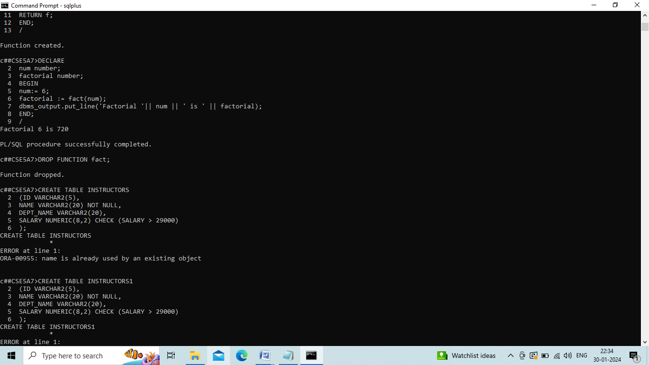

**CONCLUSION:** In this lab, we successfully practiced PL/SQL program to implement stored function.

## EXP-15

CREATING TABLE:

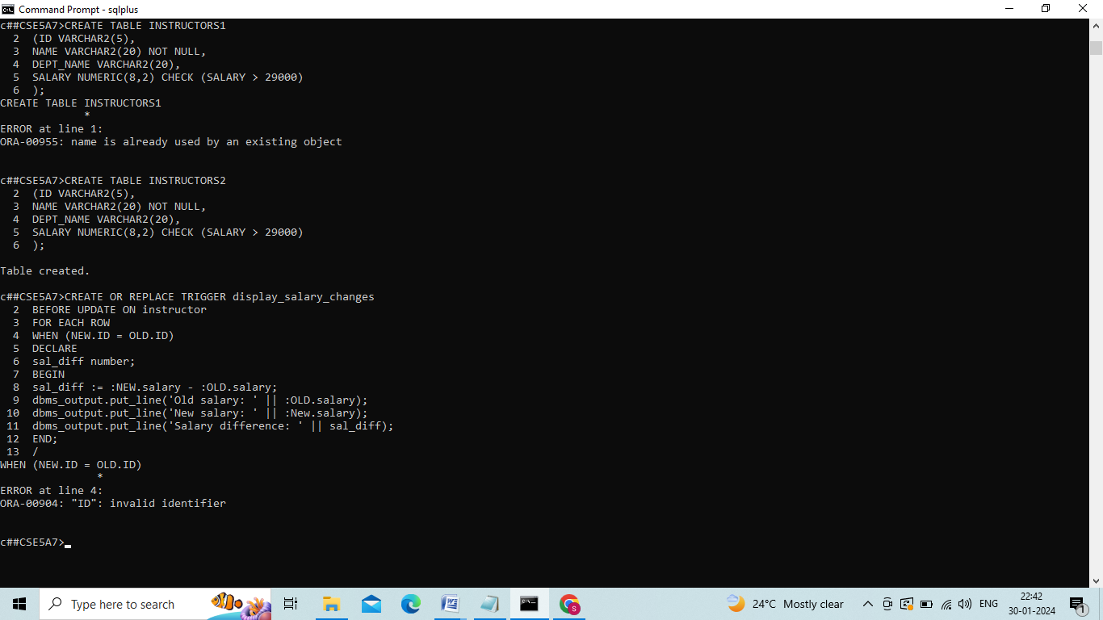

CREATING TRIGGER:-



PROGRAM:

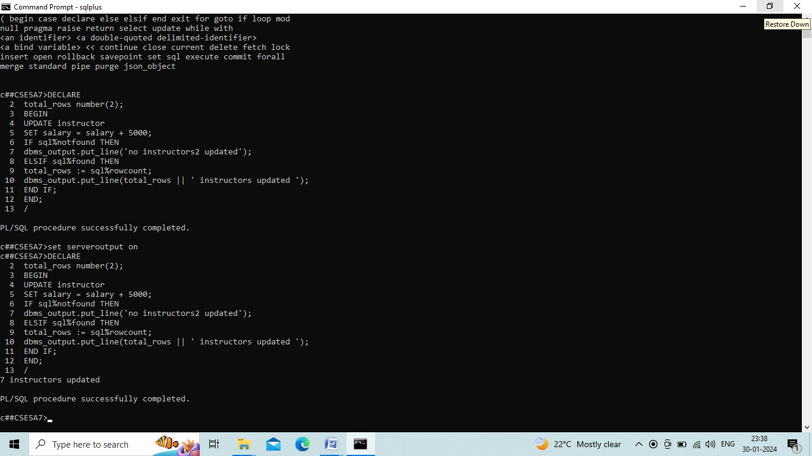

**CONCLUSION:** In this lab, we successfully Executed PL/SQL Program to implement Trigger on Table.

## EXP-16

CREATING TABLE:

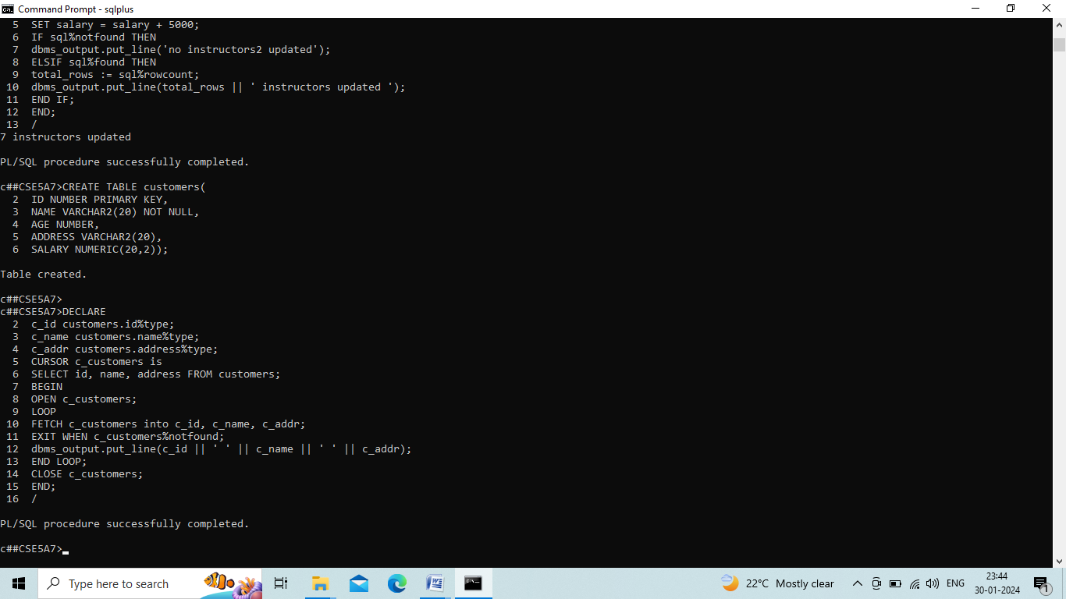

PROGRAM:



**CONCLUSION:** In this lab, we successfully PL/SQL program on implementing cursor.